**Anthony’s Drawing:**

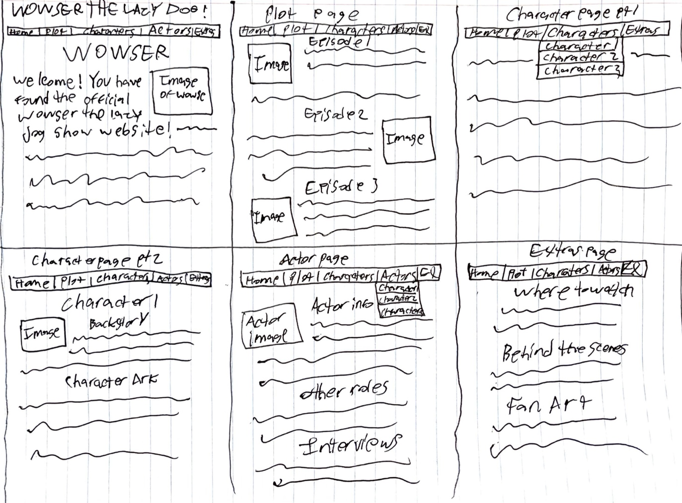

*Comments:*

My headspace with this was to allow for optimal space to provide further details regarding each category of information in an aesthetically pleasing way. One big challenge for something like that, that the website of our choosing failed at, is proper spacing. One thing I did as a means of making a better use of space is dividing up a menu bar, so far as to even create sub menus. Another thing I did as a means of adding more information was creating the tabs for plot and characters separately, actors and characters separately, and even added an extras tab for things like fan art and links to watch or buy the episodes, as well as I had the idea to potentially add interviews with cast members to provide fans with further insight as to who plays their beloved characters. All in all, I liked grouping things with the tabs menu, as it allows for things to not be so crowded, and it also allows for expansion of information in a way that is easily navigable, and precise.

**Chenxu’s Drawing:**

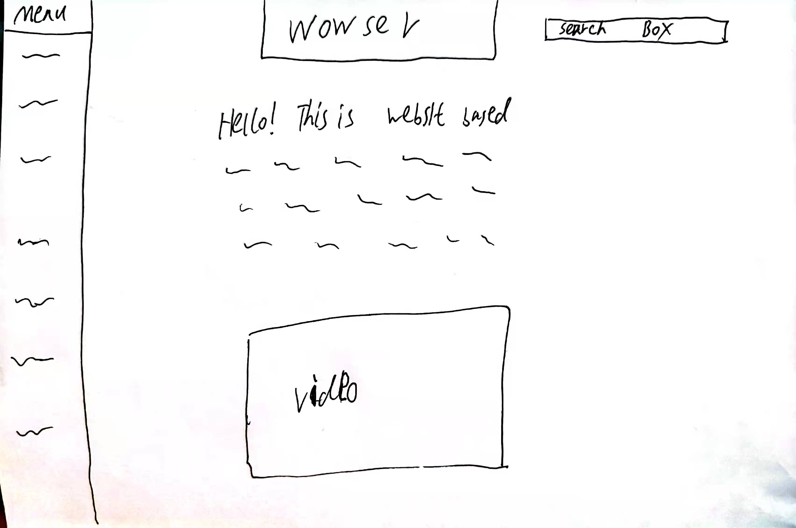

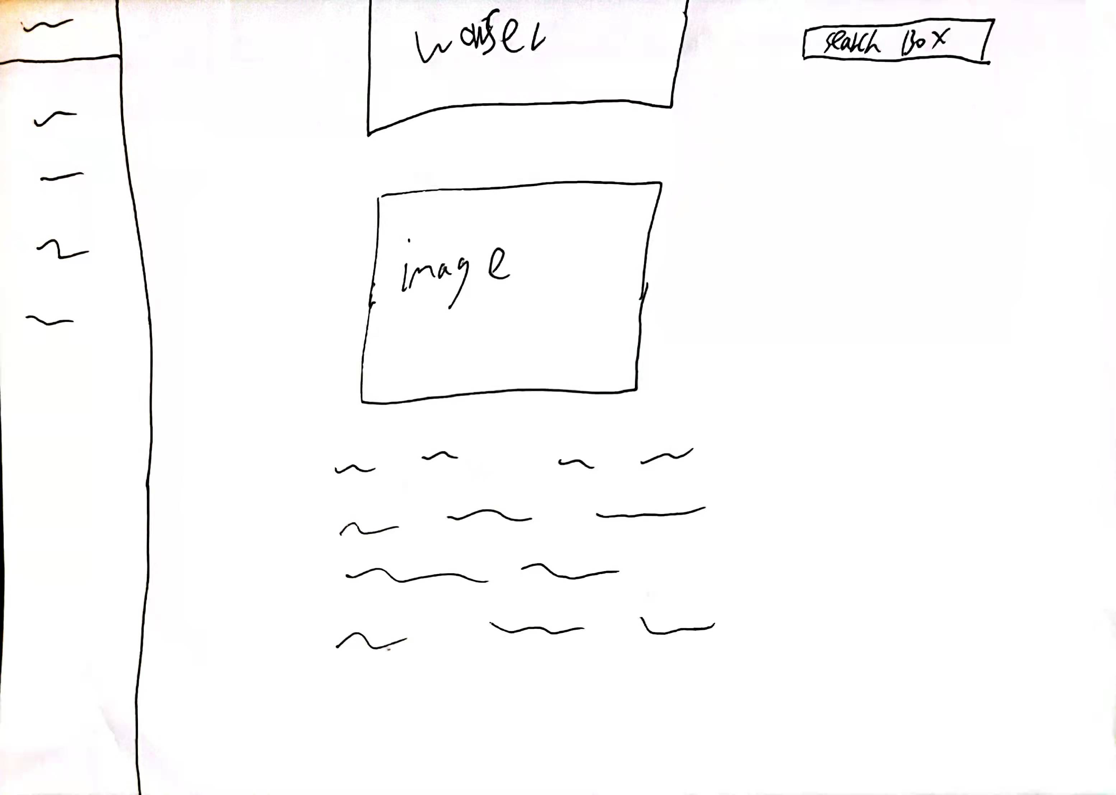

## Comments: The first picture, I put Wower’s title at the top center to make it clear and Obvious. The instruction text is at the center with a video about Wower below. At the right, it’s a search box to help people search the information they want. And at the left, it’s navigation area. If people click any button at right, they will get a website like second picture. Most distribution are the same as the first picture, but this time there is a picture, and text are below. It helps people to navigate information quickly. At the right, the button that people clicked will replace the Menu in the first picture. And the buttons below will be the detail options about the button that people clicked.

**Chris K’s Drawing:**

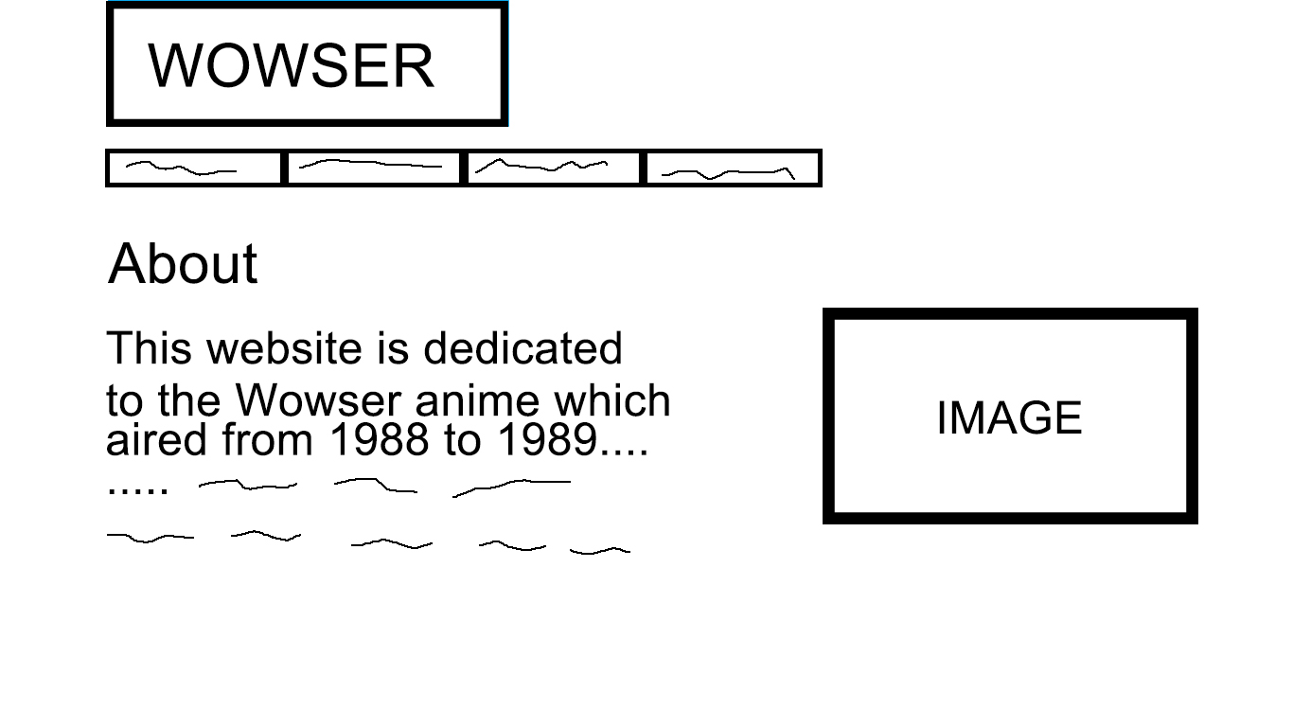

*Comments:* Excess information on the front page is moved to the “About” section. Unlike the original design, text will follow human-centered design principles. The text should be black, use a readable font, a simple background, and be aligned to the left.

**Chris P’s Drawing:**

**Home Page:**

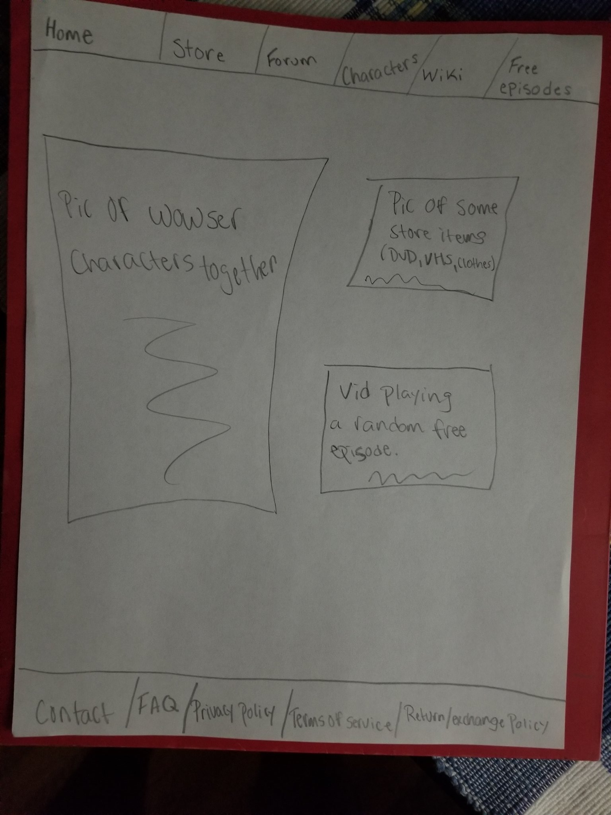

**Store:**

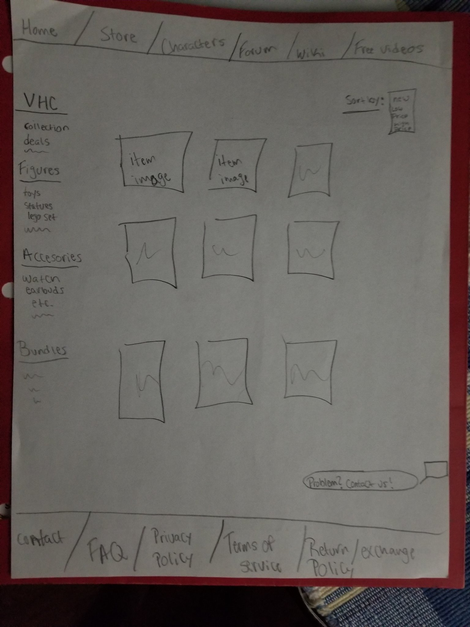

**Forum:**

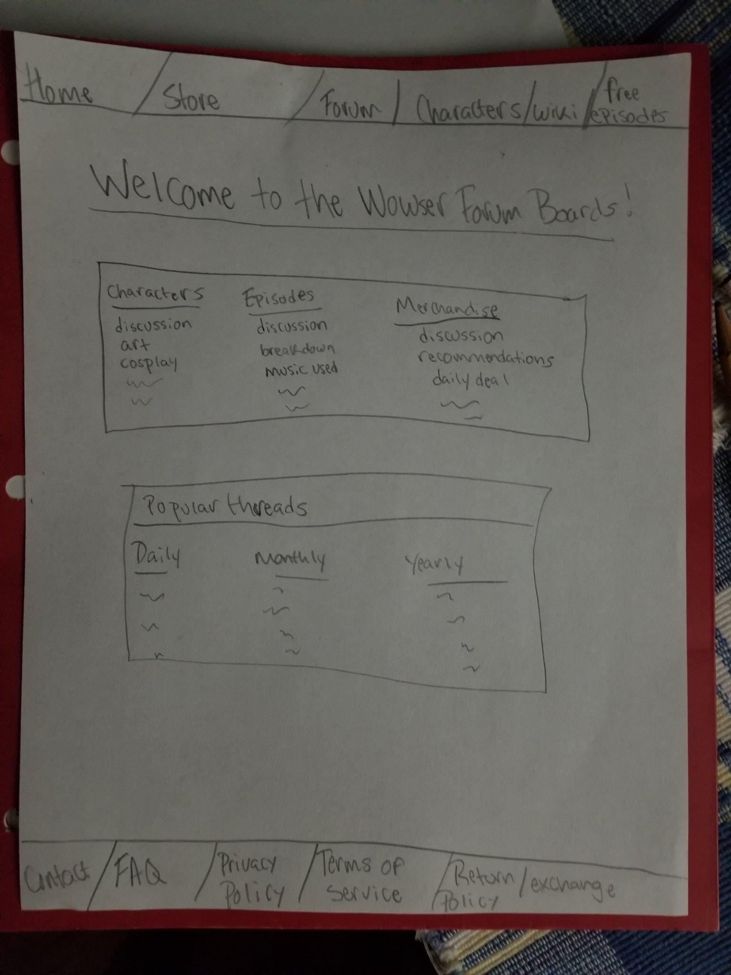

*Comments: I chose to make a more modern looking design. I created an easy to use navigation bar on the top and bottom of the website. When clicked they will take the user to a different part of the website. I tried to incorporate some of the different parts on the website in the home page; pic of Wowser characters, some of the merch the store offers, and a video of a random episode of Wowser.*

*For the store page I used a similar design to amazon. I have the different types of purchasable merch organized into different categories on the left. Also, I added a sort by button on the top right that allows users to choose how they want to sort through the different merch*

*I wanted to create a page in which users can communicate with each other anonymously and with the need of a password (like the website 4chan). I created a forum board that allows users to discuss various topics related to Wowser.*

**Kasius McCall Drawing:**

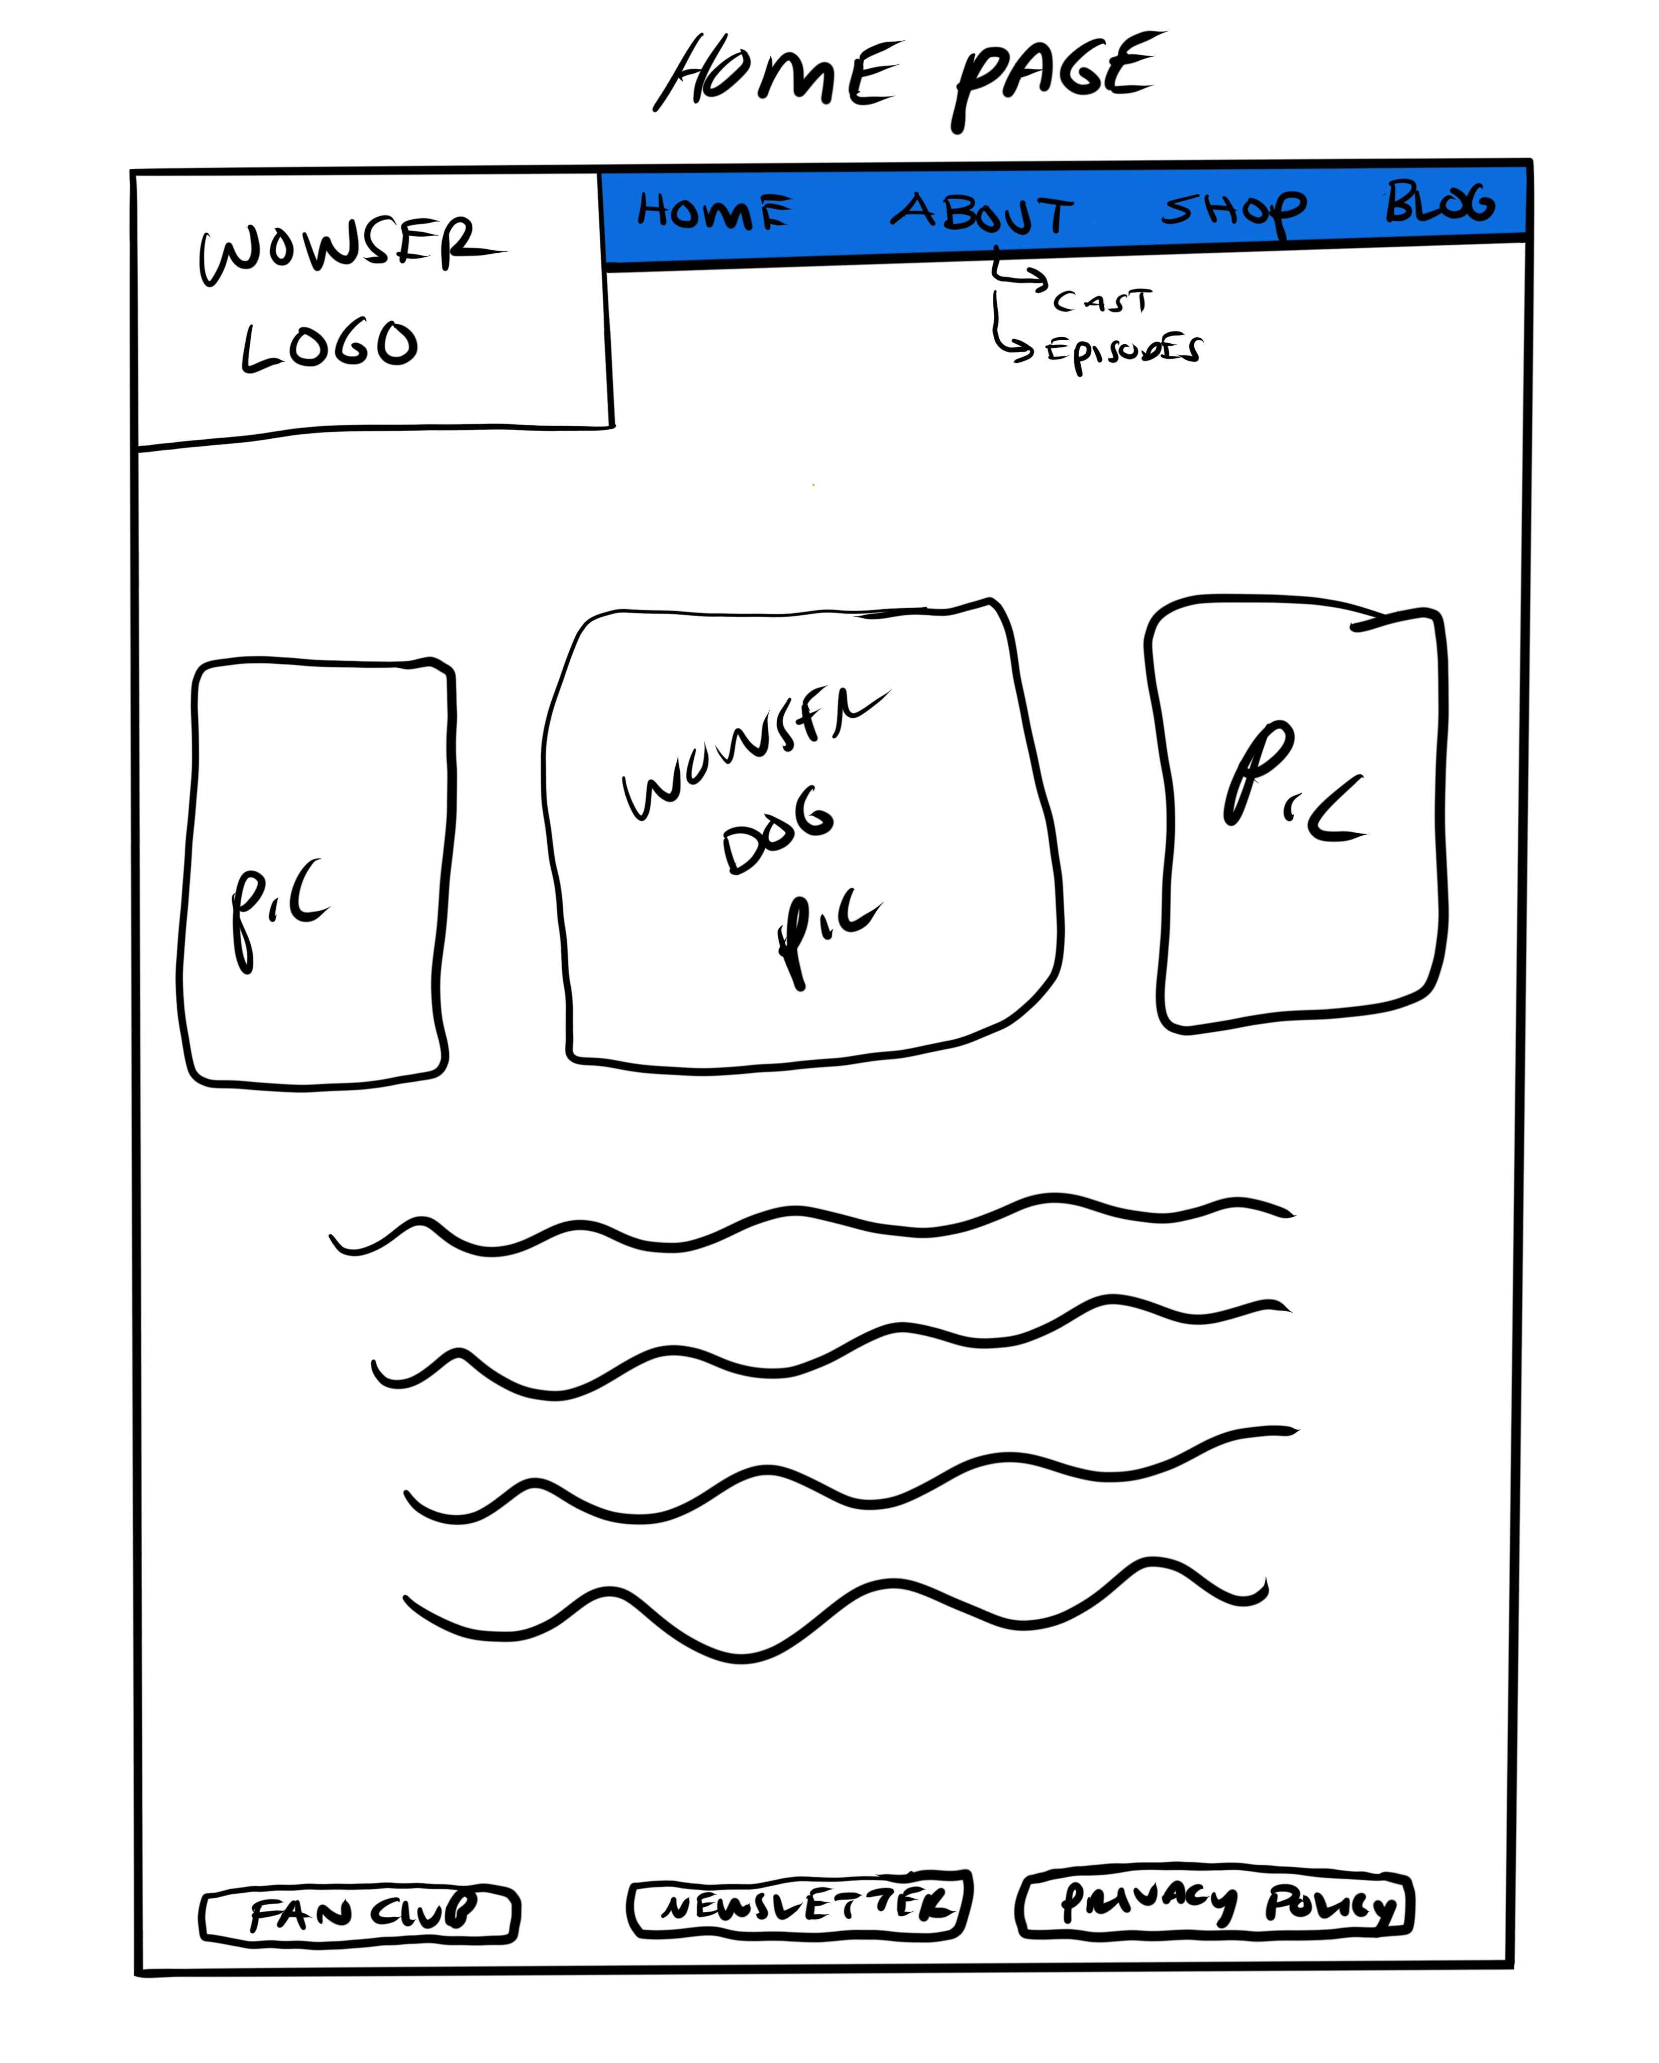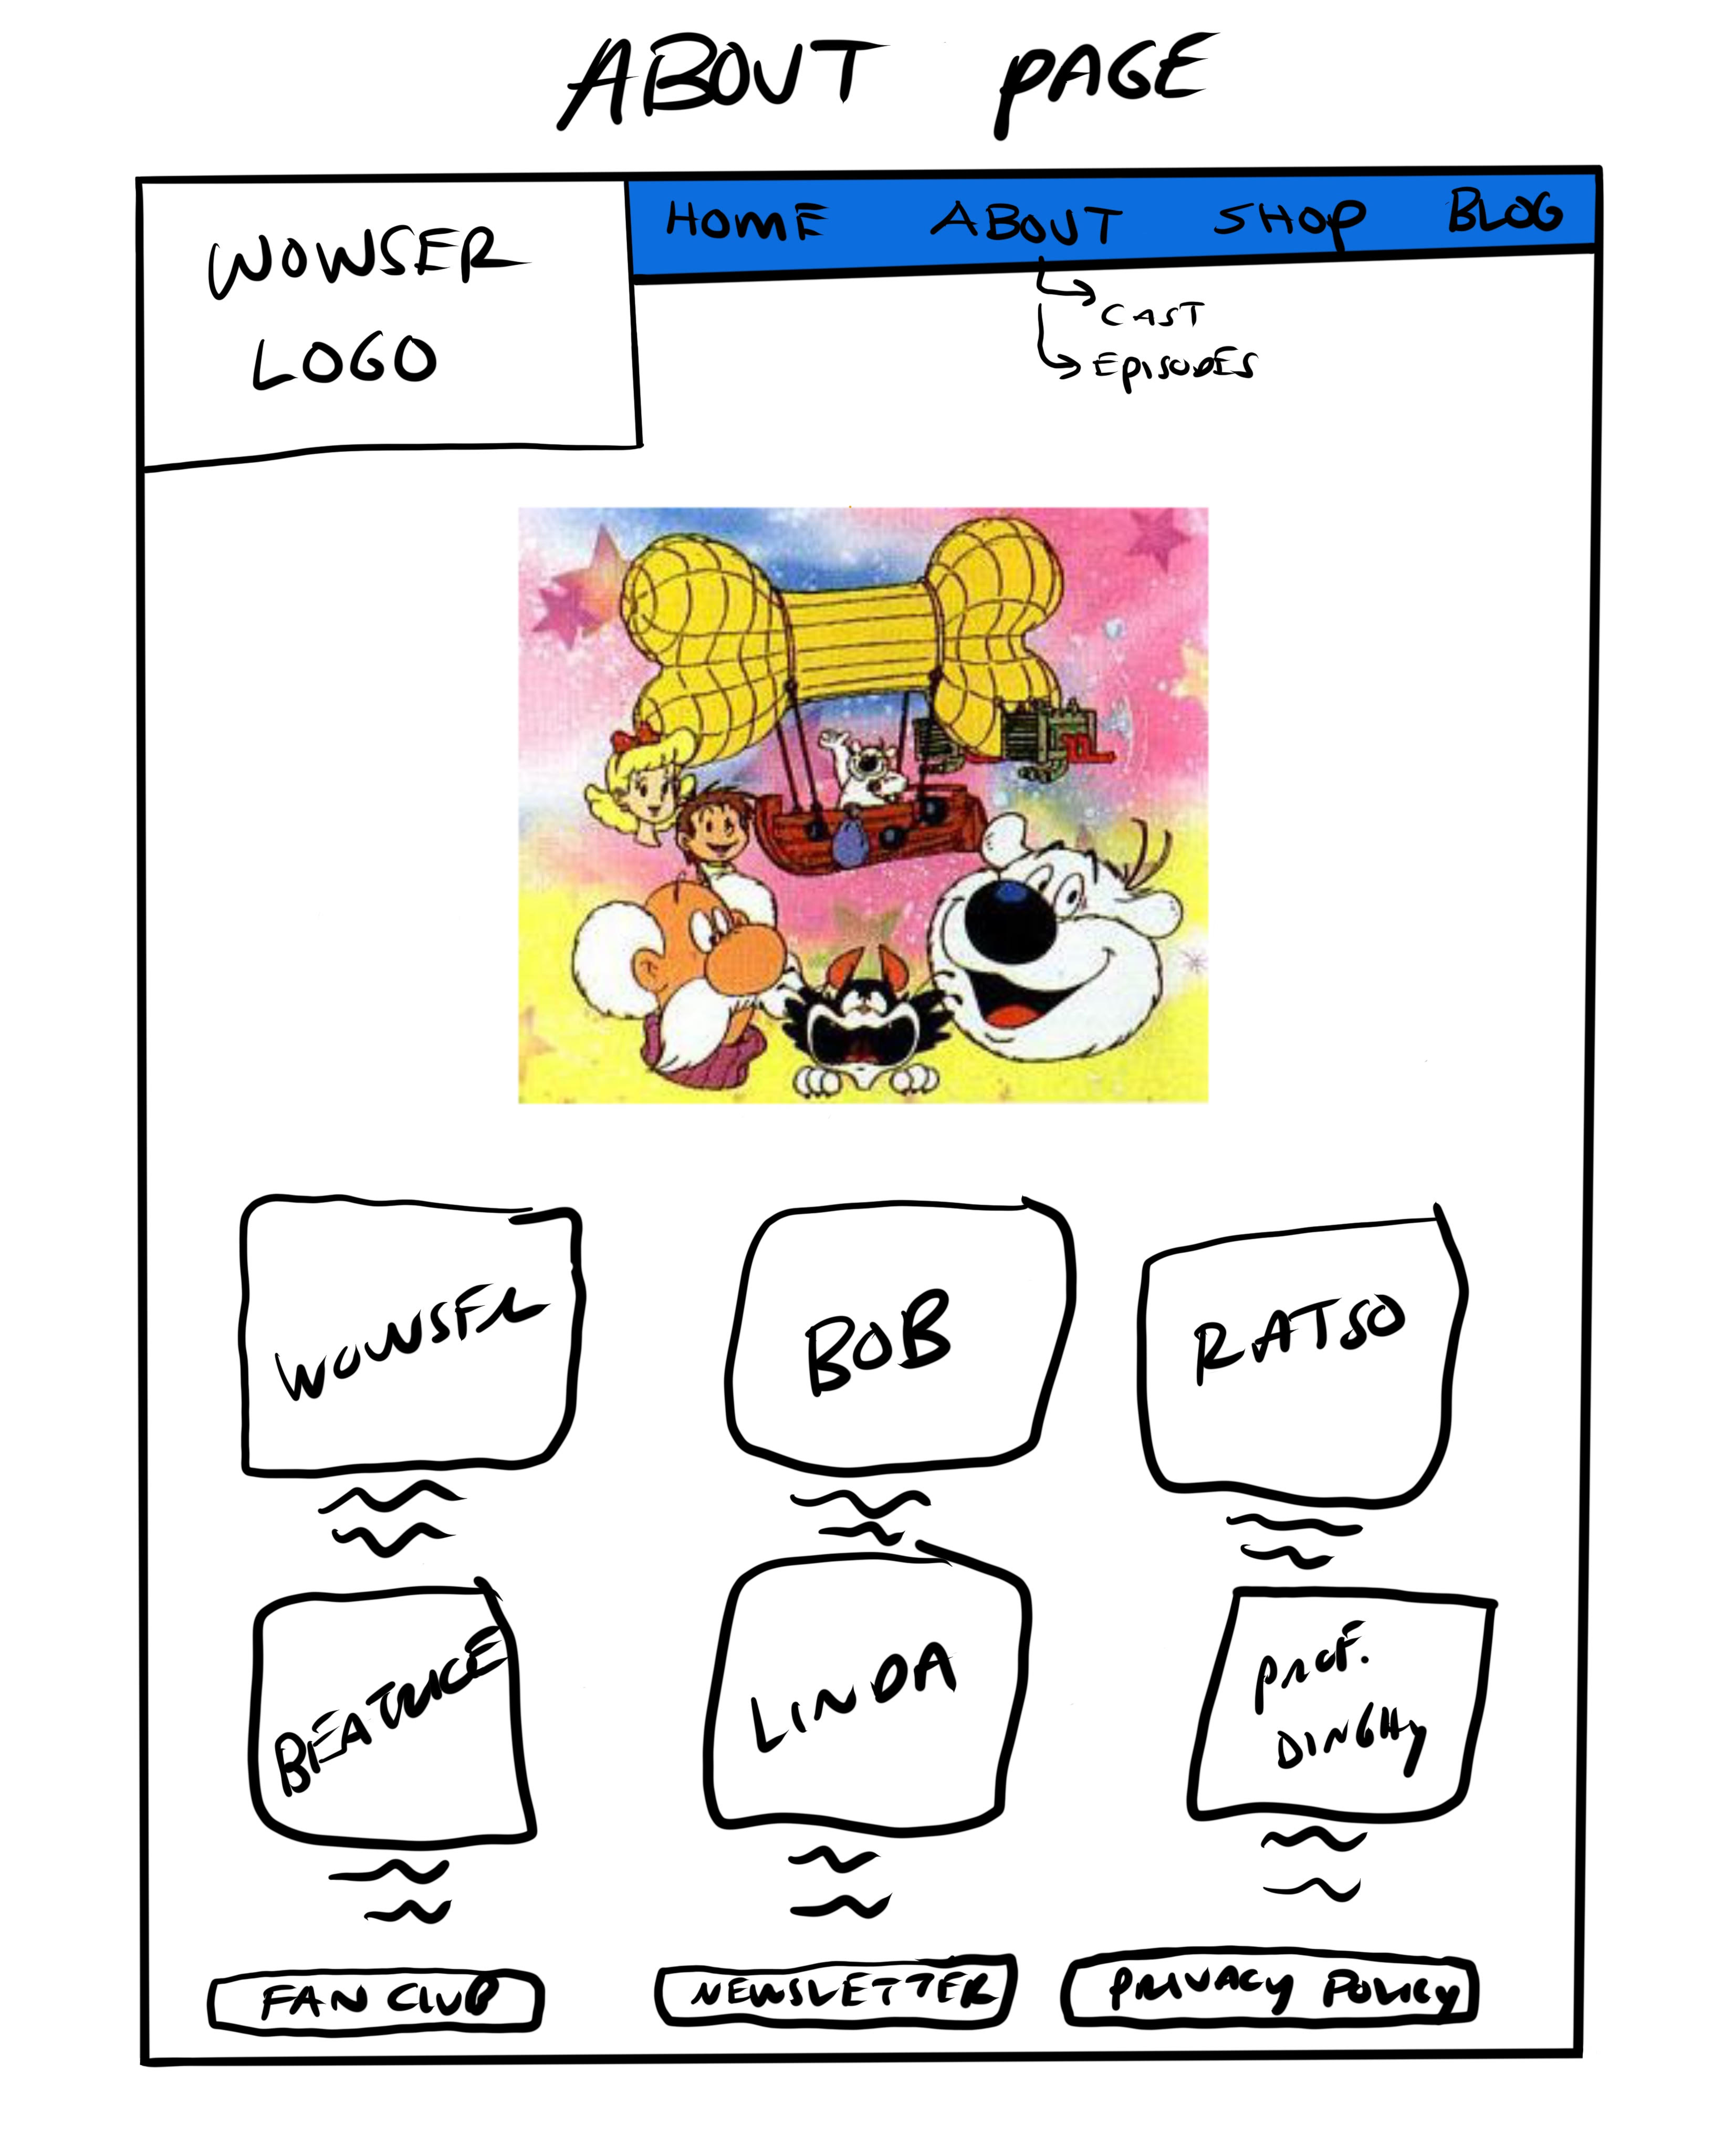

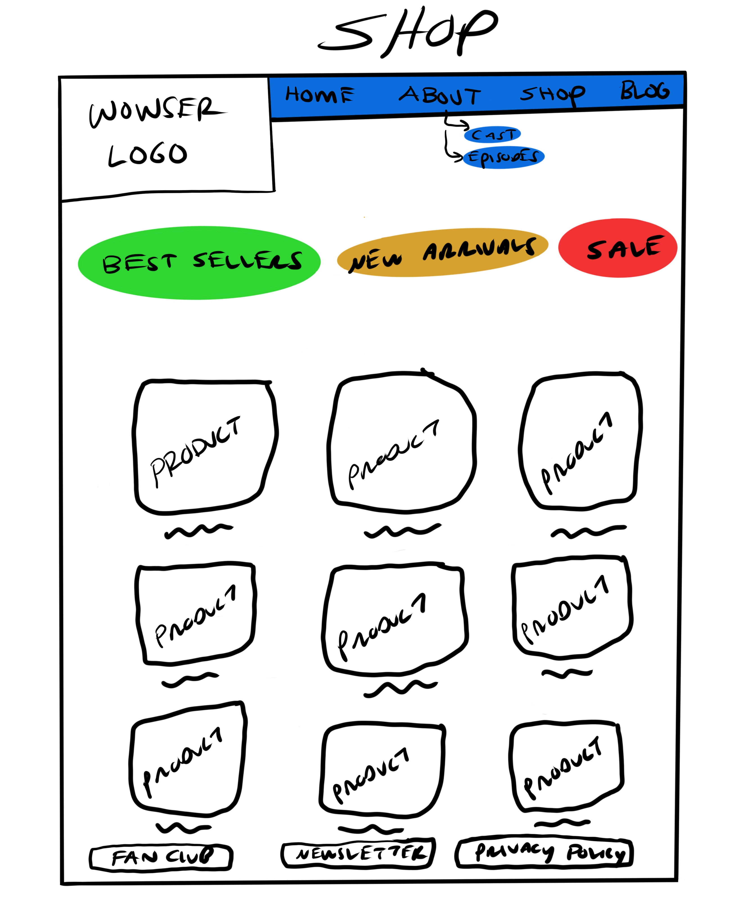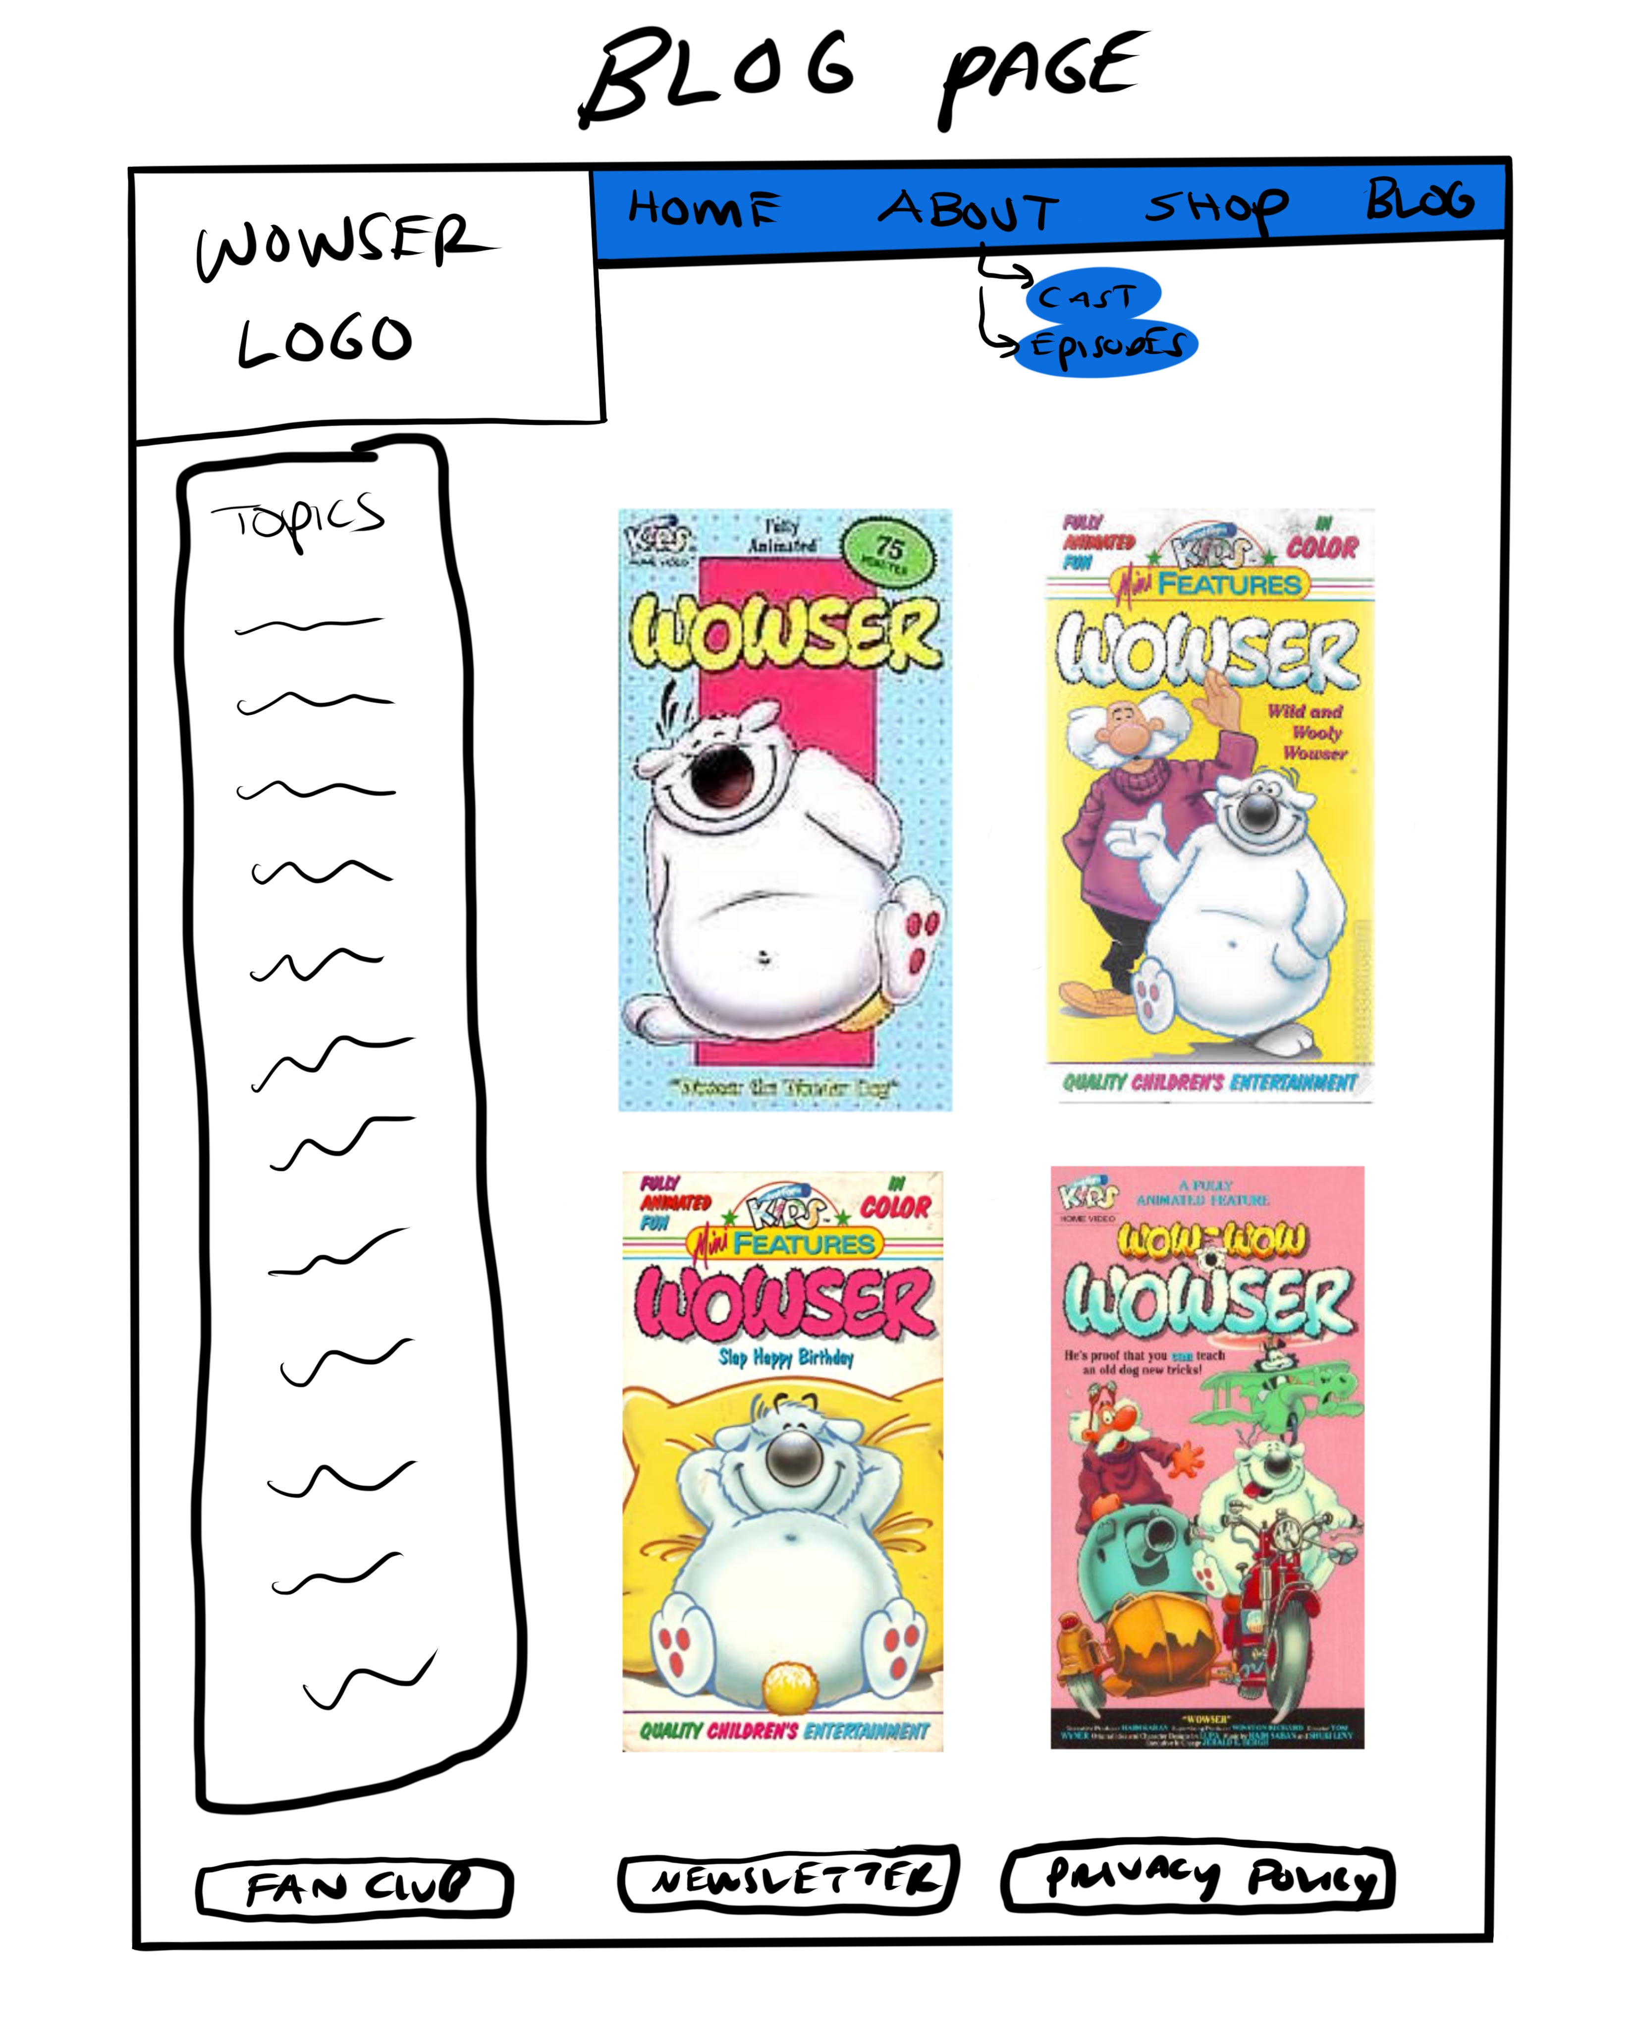

*Comments:*

So, for my Wowser website, I went for a minimalist look with pops of color to bring out the modern side of it. Everything is easy to navigate and find so that anyone can interact with the website. Because there is not a ton of information to pack into this website, it needs to look clean and full, without being barren like the original website.

**Group Low-Fidelity Prototype:**

Home Page- Chenxu

Character Page - Anthony

Plot page – Anthony

Blog page – Kasius

Shop - Kasius

Forum Board – Chris P

About Page – Chris K

*Comments:*